Create web UI for Crop recommendation
Step1- Develop, save and deploy machine learning model for crop recommendation using watsonx.ai studio as per the steps mention in PDF

Step2- From cloud.ibm.com use the API key and model end point
Login – Manage – Access (IAM) – API Keys – Create – Name (croprecommendation) – Create – Copy/Download (Save this API key on notepad)
Step3 – From cloud.ibm.com copy Public endpoint of deployed model
https://au-syd.ml.cloud.ibm.com/ml/v4/deployments/047c06d0-c49a-4994-bdb9-f2acd9d8918f/predictions?version=2021-05-01
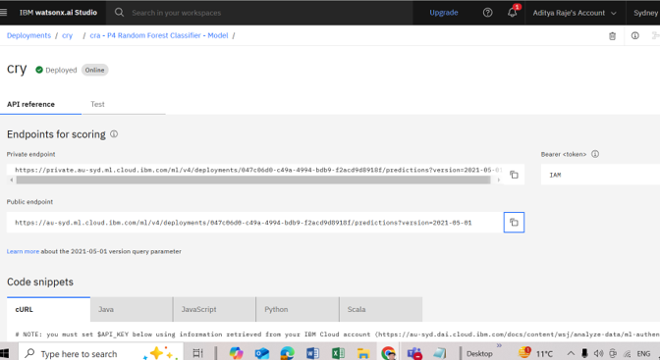

Step- create folder webuicroprecommendation
F:\SB4C_BootCamp_Content\webuicroprecommendation
Step- Open command prompt and reach to folder location
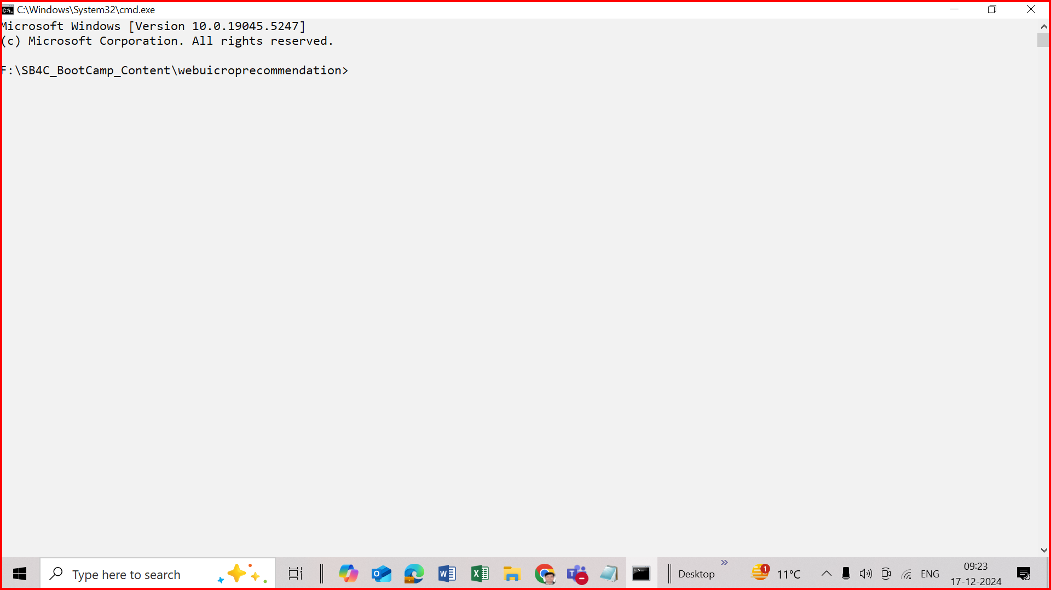

Step- install python

Step – install Django
pip install Django
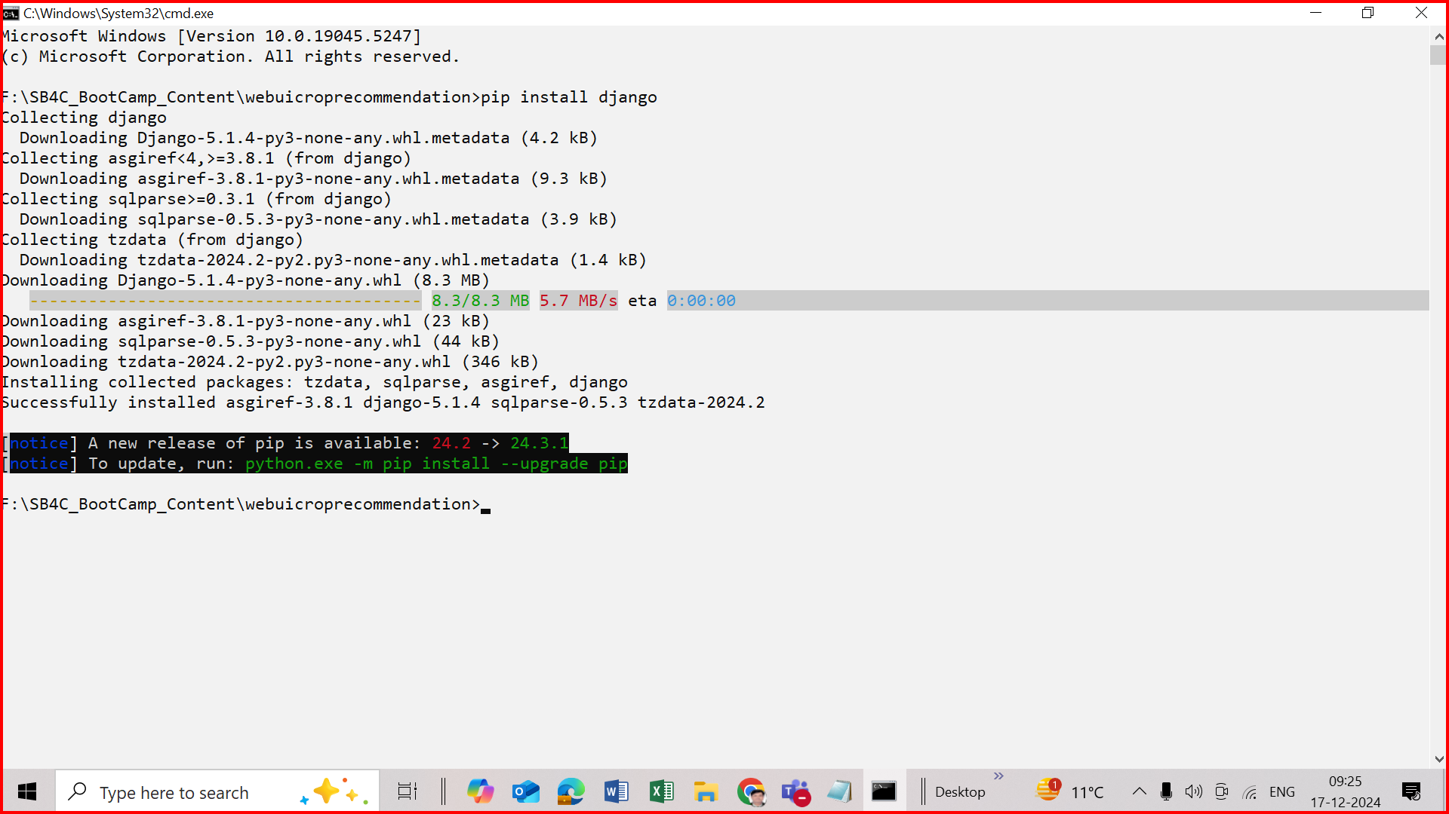

Step- clone the project from github

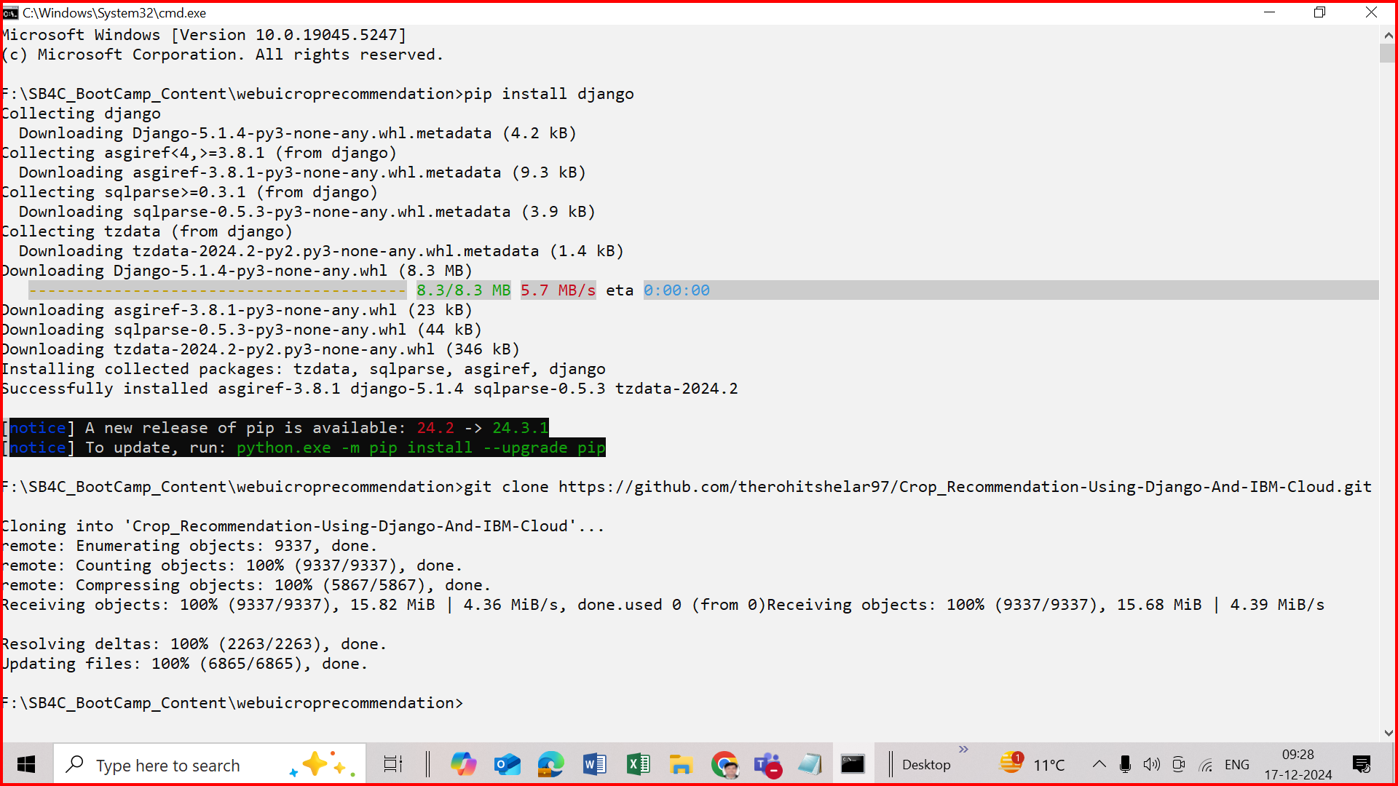

Step – reach to folder location \webuicroprecommendation\Crop_Recommendation-Using-Django-And-IBM-Cloud\crop_prediction
cd F:\SB4C_BootCamp_Content\webuicroprecommendation\Crop_Recommendation-Using-Django-And-IBM-Cloud\crop_prediction
step- open views.py in editor
webuicroprecommendation\Crop_Recommendation-Using-Django-And-IBM-Cloud\crop_prediction\myapp\views.py
Paste your API Key into variable API_KEY=” “
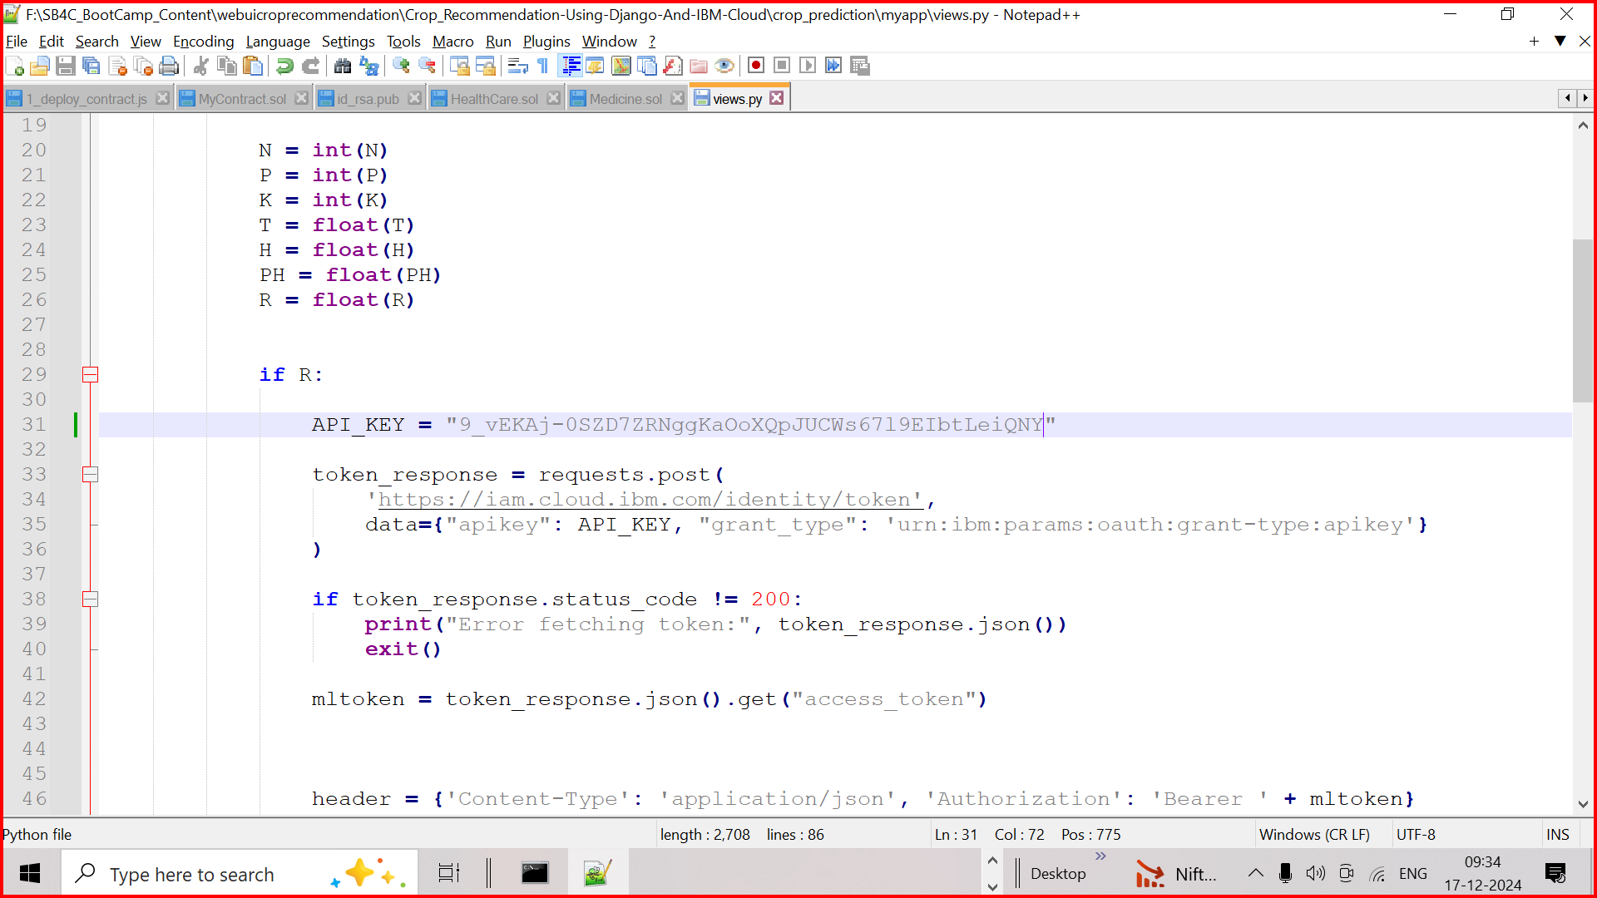

Step -Paste model Public endpoint in the views.py file
response_scoring = requests.post(
' https://au-syd.ml.cloud.ibm.com/ml/v4/deployments/047c06d0-c49a-4994-bdb9-f2acd9d8918f/predictions?version=2021-05-01',
json=payload_scoring,
headers=header,

)

Save file views.py
Return to cmd

Step –
pip install requests
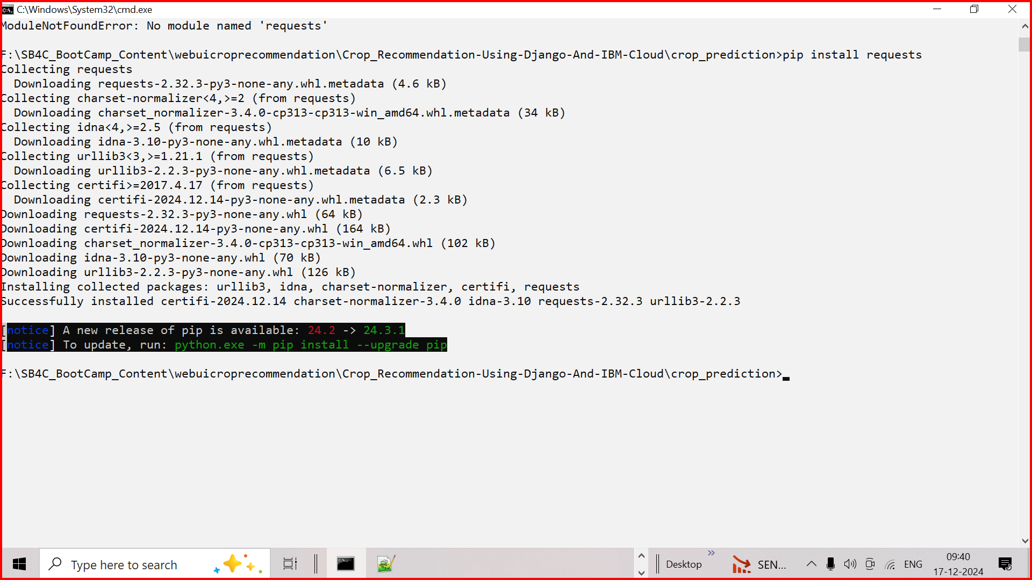

Step- run project
python manage.py runserver
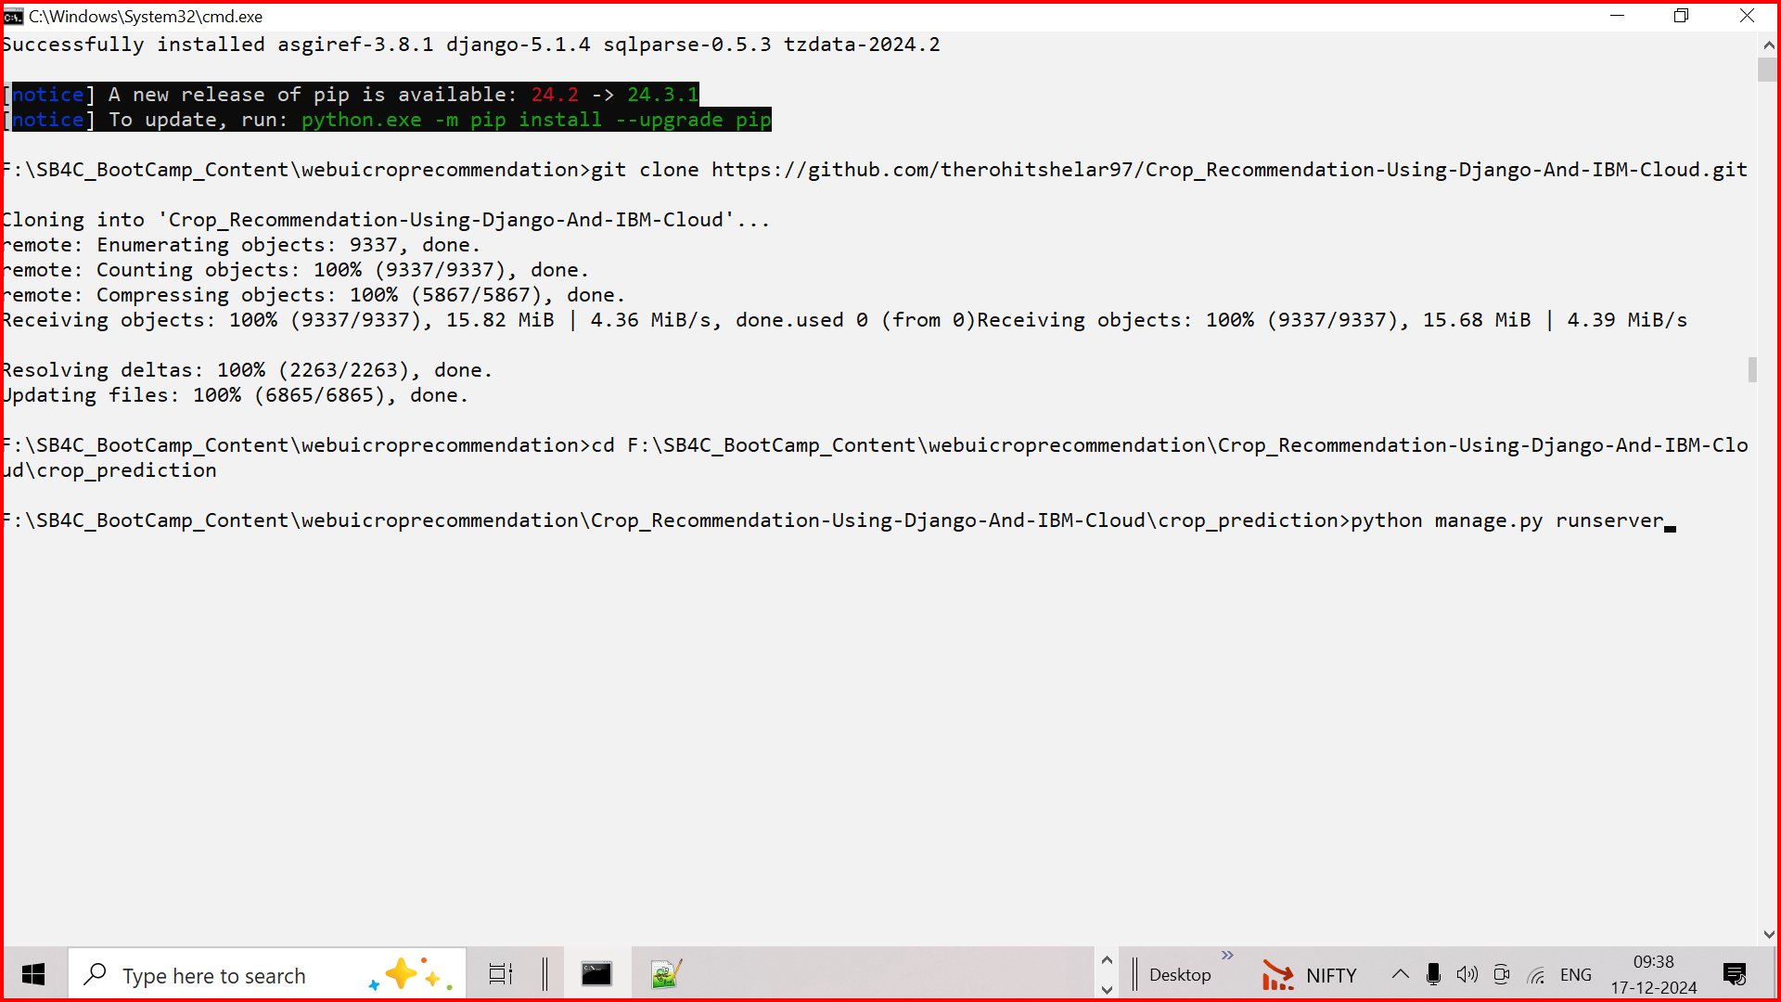

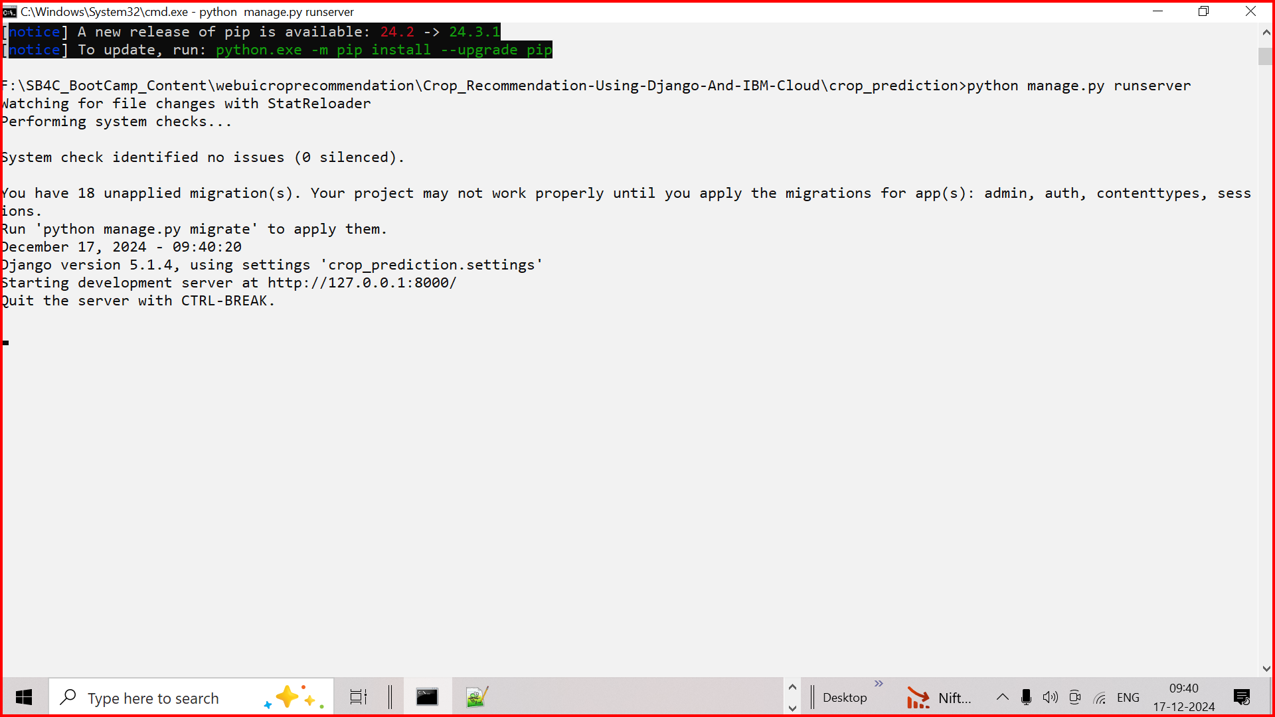

Open browser http://127.0.0.1:8000

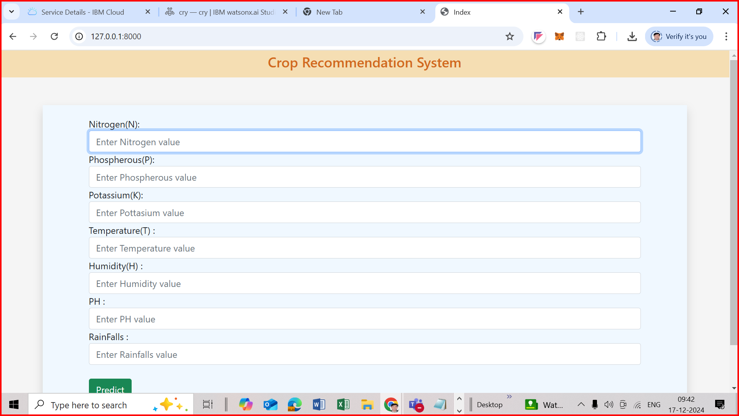

Give value
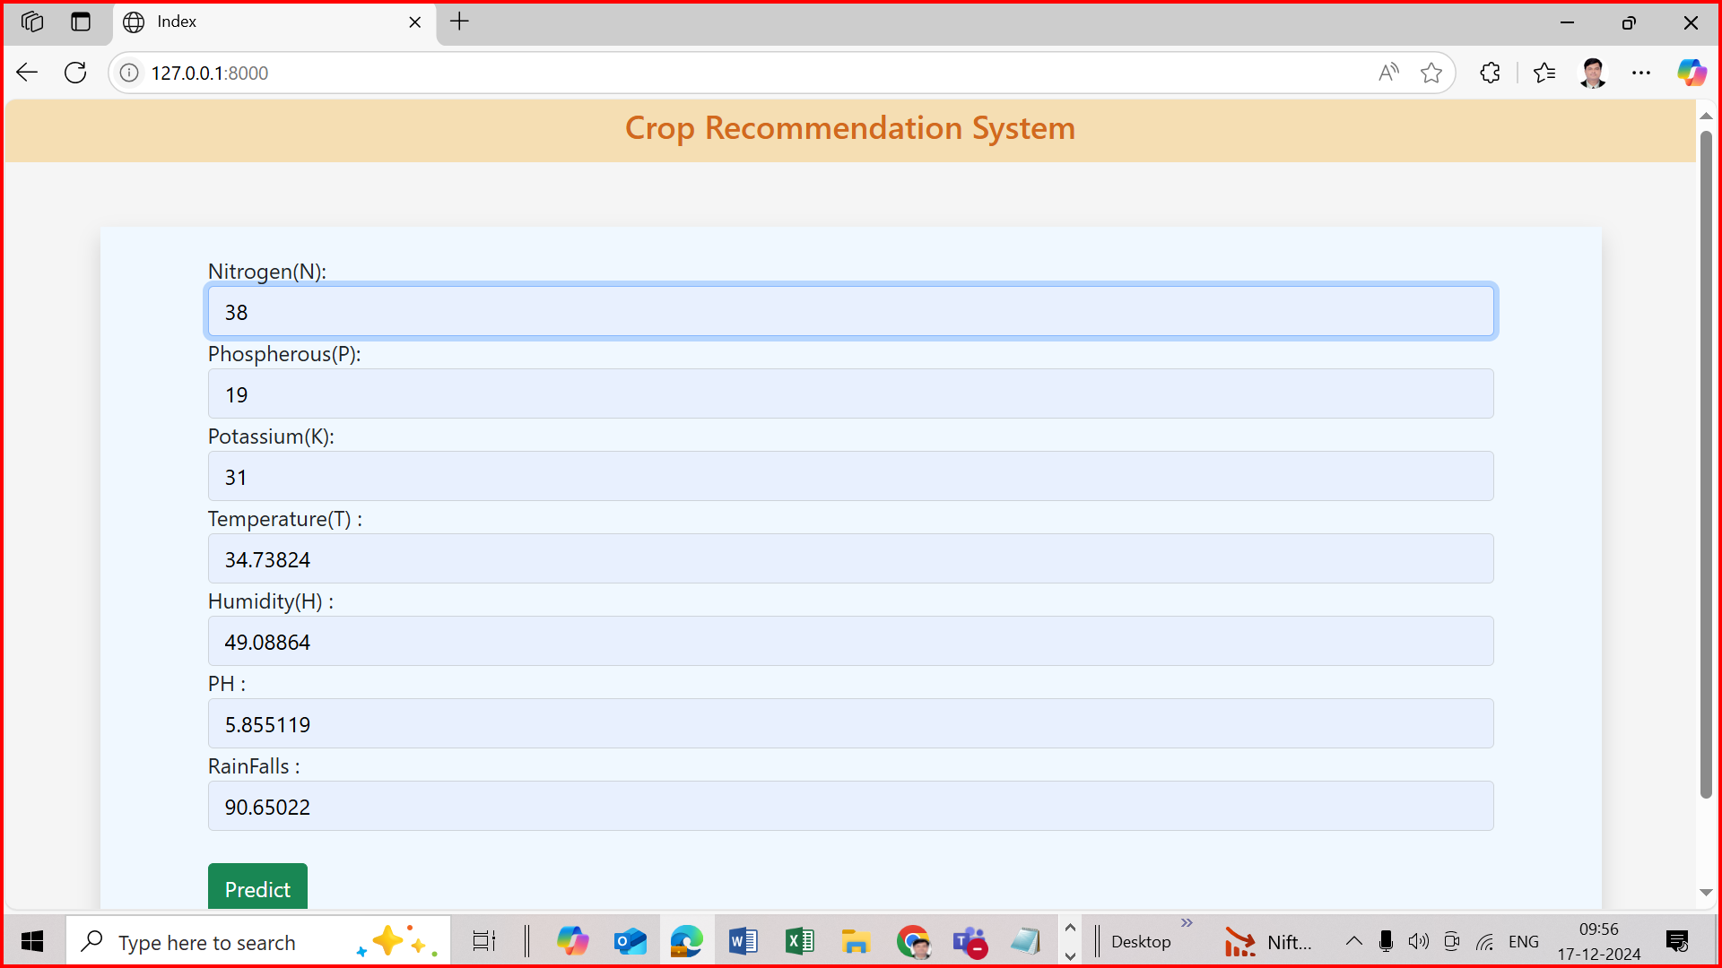
It will show output Mango
